Power Conversion Card (PCC)
Phase 2 - Conversion

Hardware Design Document (HDD)

Revision B

Ownership Disclaimer
This document contains proprietary and confidential material that is the sole property of Compressor Controls Corporation. The information contained herein is intended for internal use by Compressor Controls Corporation employees and is not intended for distribution outside of the company. As an unpublished work of trade secrets, the recipient shall keep this document confidential. Any re-use, copying, or distribution, either in whole or in part, of this material without the express written consent of Compressor Controls Corporation is strictly forbidden.
Copyright © 2015 by Compressor Controls Corporation. All rights reserved.
Revision History

Revision | Date | Description | Author
A | 2nd May 2013 | Initial release | Manjunath M
B - Phase 2 | 5–Jun-2015 | Phase 2 Conversion | Muthuvelu.D

Approvals

Product Manager Date

Table of Contents
1 Introduction 5
1.1 Purpose 5
1.2 Audience 5
1.3 Scope 5
2 General Description 6
2.1 Board Features 6
2.2 Implementation Block Diagram 7
3 Description of Functional Blocks 8
3.1 Surge stopper & Hot swap for 24V_A and 24V_B Power Bus 8
3.2 Differential Mode Filter 10
3.3 Power and Voltage Measurement 10
3.4 Protection for 24_F_OUT 11
3.5 24V to 6.5V converter (DC-DC Controller) 13
3.6 24V to 3.3v conversion 17
3.7 On Board temperature Measurement 18
3.8 EEPROM Interface 19
3.9 I/O Expander Interface 20
3.10 FAULT LED circuit 21
3.11 ALARM LED Circuit 22
3.12 I2C Communication Block diagram 23
3.13 Redundancy 24
3.14 24V_A / 24V_B / Board indicating Front Panel LEDs 25
3.15 I2C Device Address 25
3.16 PCC Card connector 26
3.17 Card Guide connector 28
3.18 Loss Estimation of the PCC Card @ full load. 29
3.19 Front Panel LEDs List 29
4 Schematic Design 30
4.1 Design Tool 30
5 Board Layout Design 30
5.1 Board Thickness 30
5.2 Board Stack-up 30

Introduction

Purpose
The objective of this document is to describe the hardware design of Power Conversion Card (PCC Card).

Audience
This document is targeted at Personnel involved in development and testing of board at Mindteck as well as CCC.

Scope
The scope of this document is to describe PCC card hardware design in brief. The document details the various functional level block diagrams.

General Description

Board Features

Sr. No. | Feature | Description
1 | Hot swap and Surge stopper | Surge stopper and hot swapping function for 24V_A and 24V_B Bus
2 | Power/Voltage on board measurement | On board current and Voltage monitoring of the 24v on PCC
3 | Short Circuit Protection on 24V_F_OUT | Reverse Polarity and current limit protection on 24V_F_OUT DC Bus
4 | 24V to 6.5V conversion | DC-DC controller for 24V to 6.5V
5 | 24V/6.5V to 3.3V conversion | LDO for 3.3v generation
6 | On board temperature measurement | Digital temperature measurement on PCC Board
7 | EEPROM Interface | Board information storage on PCC
8 | I/O Expander Interface | Input and Output pin expander IC
9 | Alarm LED Circuit | Software controlled Alarm signals to indicate error signals
10 | Fault LED Circuit | Software and Hardware controlled signal to indicate faulty situation
11 | 24V DC Bus LEDs | Front panel LED to indicate the presence of the DC Bus
12 | Board Indicating LEDs | Board indicating LEDs for service men
13 | I2C Communication | 2-wire communication with IES processors
14 | I2C Device address | Unique address for each I2C device
15 | Back Plane connector | PCC to Back plane connector
16 | Card Guide connector | Card guide to fix on backplane for mechanical strength.

Implementation Block Diagram

The implemented block diagram is shown below.
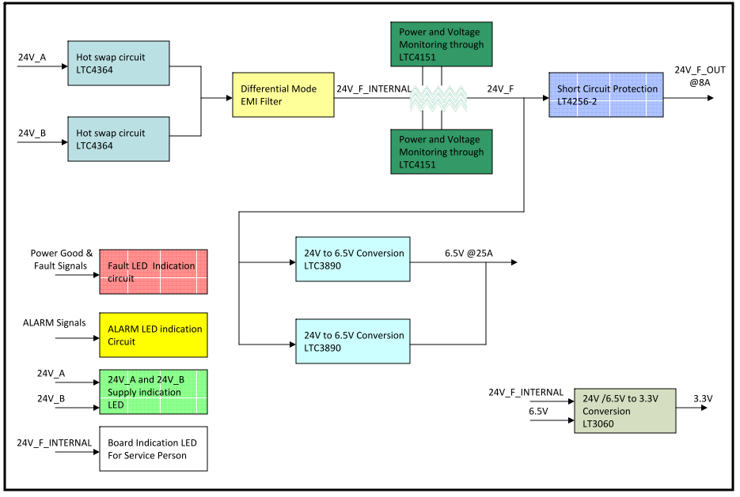

Description of Functional Blocks

Surge stopper & Hot swap for 24V_A and 24V_B Power Bus

NGP system receives two external 24V DC Bus. So external buses have been provided hot swappable features and ORed using ideal diode. This functionality has been implemented using LTC4364HMS-2#PBF from Linear. The IC has the following features.

- Wide Operating Voltage Range: 4V to 80V
- Withstands Surges Over 80V with VCC Clamp
- Adjustable Output Clamp Voltage
- Ideal Diode Controller Holds Up Output Voltage during Input Brownouts
- Reverse Input Protection to –40V
- Reverse Output Protection to –20V
- Over current Protection
- Low 10μA Shutdown Current at 12V
- Adjustable Fault Timer

LTC4364 has been programmed in PCC Card for below functionalities

- Input Under voltage lockout of 18V
- Input Over voltage lockout/clamp of 32V
- Current Limit of maximum 12.5A
- Diode ORing for 24V_A and 24V_B DC Bus.
- Green Color LED indication for each bus.
- Transient Voltage suppressor
- PCC card would be enable only if PCC is plugged into backplane, to ensure safety.
- Fault signals of Hot swap IC is interfaced to I/O Expander to enhance safety.

Implemented Diagram In schematic is shown below:

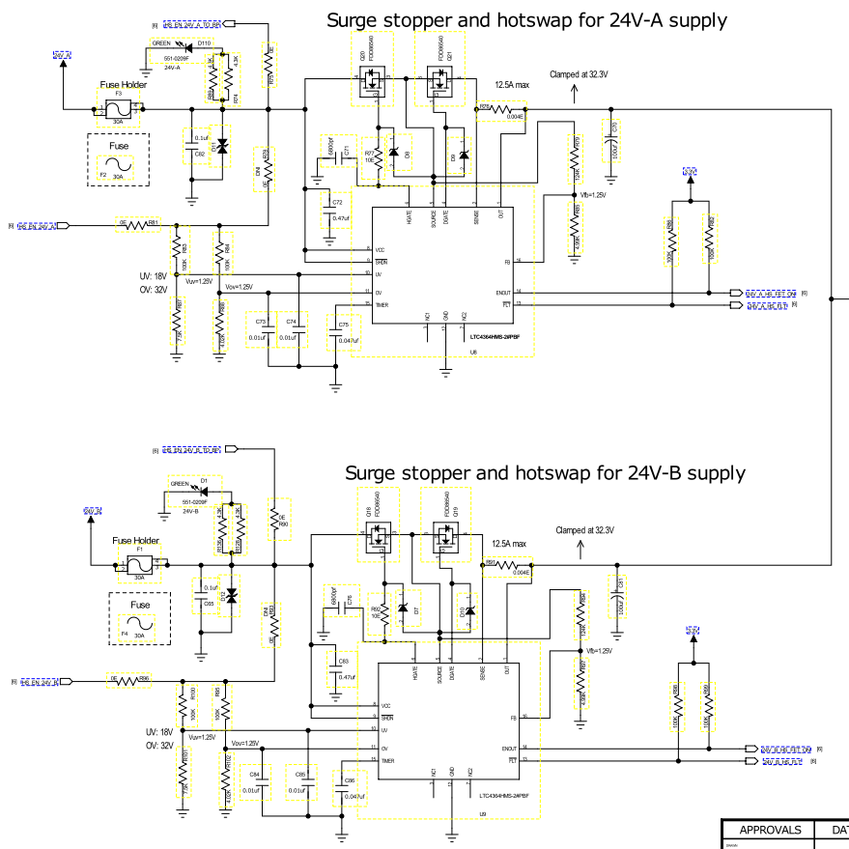

Differential Mode Filter
The PCC Card would be make use of differential mode filter to remove any noise on the incoming DC 24V Bus. Two PI filter have been used in series to give more attenuation for noise. Cut off frequency would be approximately 44Khz. below figure shows the implementation in PCC Card

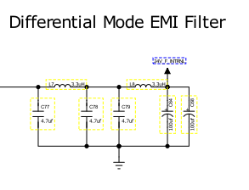

Power and Voltage Measurement
On board power and voltage measurement is done on PCC through LTC4151. The
LTC4151 is a high side power monitor that operates over a wide voltage range of 7V to 80V and consumes less than 1.7mA quiescent current in normal operation. In default operation mode, the onboard 12-bit ADC continuously measures high side current, input voltage and an external voltage. Data is reported through the I2C interface when polled by a host. A shutdown mode is available with the LTC4151 to reduce the quiescent current to less than 300µA by pulling the SHDN pin below 1V.

Features:
- Wide Operating Voltage Range: 7V to 80V
- 12-Bit Resolution for Both Current and Voltages
- I2C Interface
- Additional ADC Input Monitors an External Voltage
- Continuous Scan and Snapshot Modes
- Shutdown Mode (LTC4151) Reduces Quiescent Current to 120µA

I2C power monitoring IC has been implemented in PCC as shown below

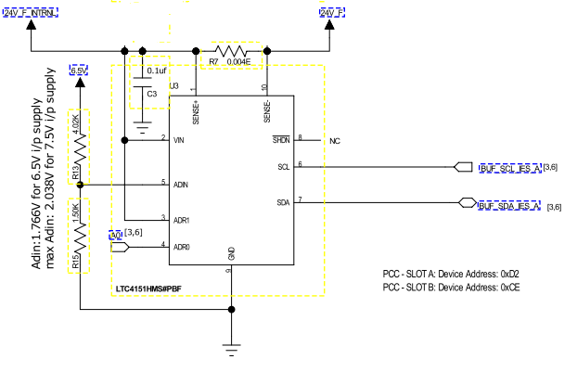
Incoming 24V DC bus is continuously monitored by the IC. Current through sense resistor is measured as differential voltage and fed to the IC (diff op amp inside) and measured through 12 Bit ADC and information is sent to IES Processor. And internal ADC also monitors the 6.5V output of the DC-DC Controller. Since internal ADC has a mux logic, it switch to an one of the measurement. Another set of same circuit is developed in parallel to provide redundancy.

Protection for 24_F_OUT
There is need in NGP system, IOP Boards require 24V@8A and this line has to current limited and protected. This is implemented by LT4256-2IS8. The LT4256-2 is positive high voltage Hot Swap controllers that allow a board to be safely inserted and removed from a live backplane. An internal driver drives an external N-channel MOSFET switch to control supply voltages ranging from 10.8V to 80V. IC features an adjustable analog fold back current limit. If the supply remains in current limit for more than a programmable time, the N-channel=MOSFET shuts off and the PWRGD output asserts low. The LT4256-2 automatically restarts after a time-out delay. An external resistor string from VCC provides programmable under voltage protection.

Features:
- Controls Supply Voltage from 10.8V to 80V
- Fold back Current Limiting
- Over current Fault Detection
- Drives an External N-Channel MOSFET
- Programmable Supply Voltage Power-Up Rate
- Under voltage Protection

The Hotswap IC is programmed/implemented in PCC as shown below.

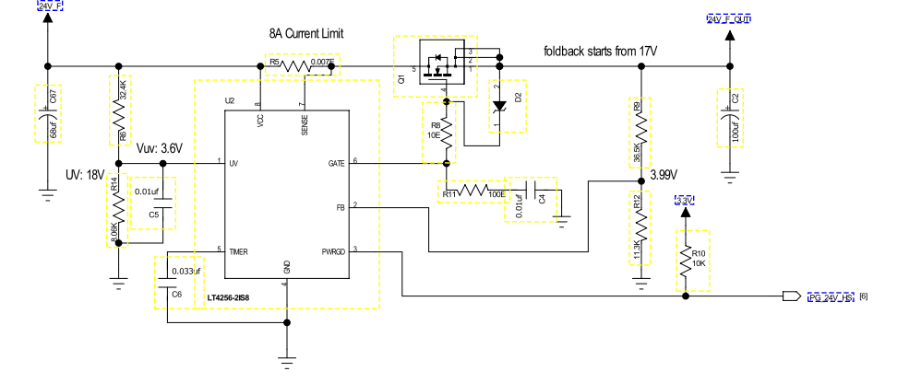
Output current has been limited to 8A and fold back starts from 17V. An under voltage lockout starts from 18V. Timer has been programmed to approximately 1.5ms to hold for current limit functionality.

24V to 6.5V converter (DC-DC Controller)
24V to 6.5V DC-DC Controller would be the heart of the PCC Card and conversion is done by LTC3890EUH buck converter chipset. The complete NGP system electronics is powered by 6.5V DC Bus. So PCC would convert from incoming 24V DC bus to 6.5V DC by using 4 phase synchronous step down conversion technology.

The LTC3890 is a high performance dual step-down switching regulator DC/DC controller that drives all N-channel synchronous power MOSFET stages. Power loss and noise due to the ESR of the input capacitor are minimized by operating the two controller output stages out-of-phase.

Features
- Wide VIN Range: 4V to 60V (65V Abs Max)
- Low Operating IQ: 50µA (One Channel On)
- Wide Output Voltage Range: 0.8V ≤ VOUT ≤ 24V
- RSENSE DCR Current Sensing
- Out-of-Phase Controllers Reduce Required Input Capacitance and Power Supply Induced Noise
- Phase-Lockable Frequency (75kHz to 850kHz)
- Programmable Fixed Frequency (50kHz to 900kHz)
- Selectable Continuous, Pulse-Skipping or Low Ripple Burst Mode® Operation at Light Loads
- Selectable Current Limit
- Very Low Dropout Operation: 99% Duty Cycle
- Adjustable Output Voltage Soft-Start or Tracking
- Power Good Output Voltage Monitors
- Output Overvoltage Protection
- Low Shutdown IQ : < 14µA
- Internal LDO Powers Gate Drive from VIN or EXTVCC
- No Current Foldback During Start-Up

LTC3890 in Poly Phase Mode (4 phase) in PCC Card.

LTC3890 is used in poly phase mode. The LTC3890 features two pins (CLKOUT and PHASMD) that allow other controller ICs to be daisy-chained with the LTC3890 in Poly Phase applications. The clock output signal on the CLKOUT pin is used to synchronize additional power stages in a multiphase power supply solution feeding a single, high current output. The PHASMD pin is used to adjust the phase of the CLKOUT signal as well as the relative phases between the two internal controllers. This means that both switches turned on at the same time, causing current pulses of up to twice the amplitude of those for one regulator to be drawn from the input capacitor . These large amplitude current pulses increased the total RMS current flowing from the input capacitor, requiring the use of more expensive input capacitors and increasing both EMI and losses in the input capacitor.

Advantages of Poly Phase operation:

With 2-phase operation, the two channels of the dual switching regulator are operated 180 degrees out-of-phase. This effectively interleaves the current pulses drawn by the switches, greatly reducing the overlap time where they add together. The result is a significant reduction in total RMS input current, which in turn allows less expensive input capacitors to be used, reduces shielding requirements for EMI and improves real world operating efficiency.

Pictorial Diagram of LTC3890

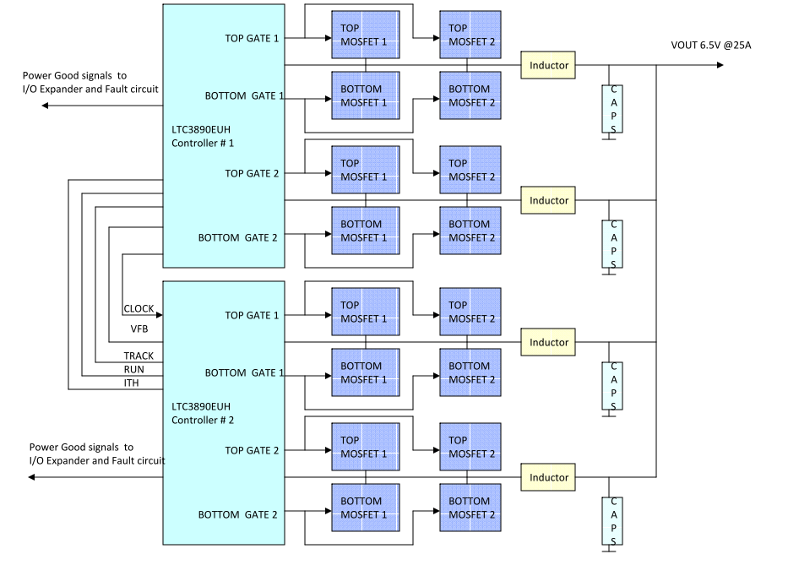

Simulation Circuit of LTC3890
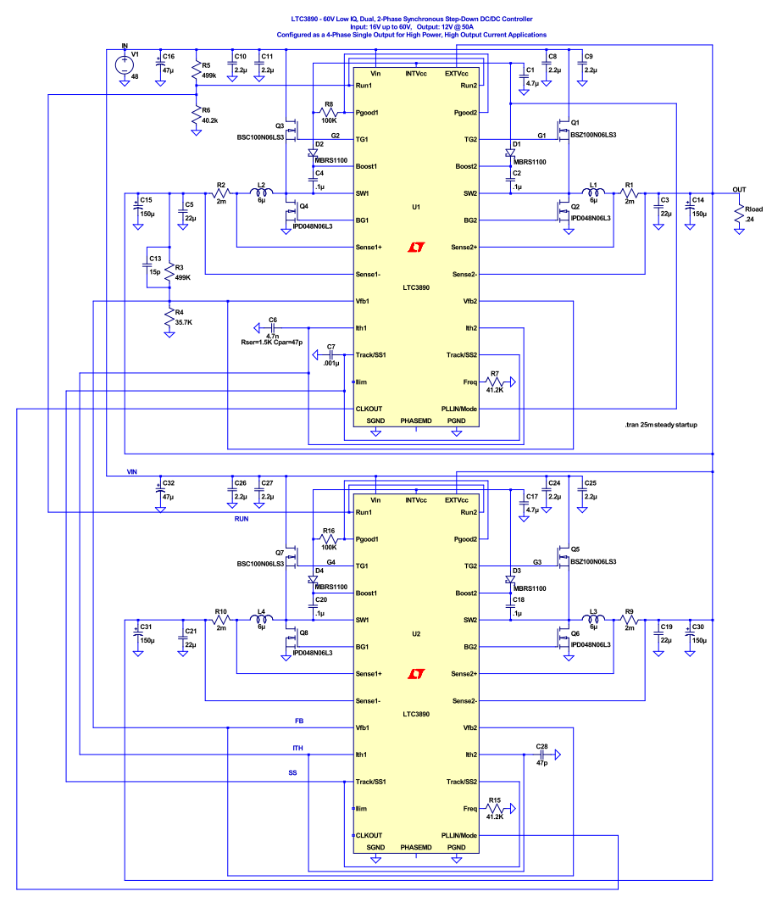

Schematic Implementation

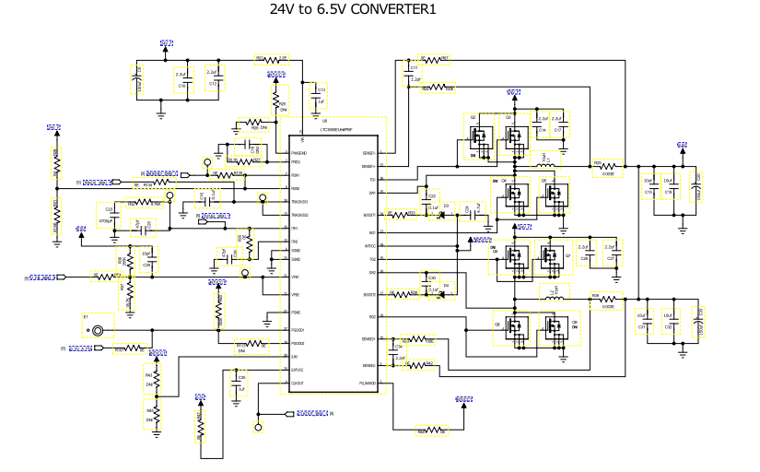
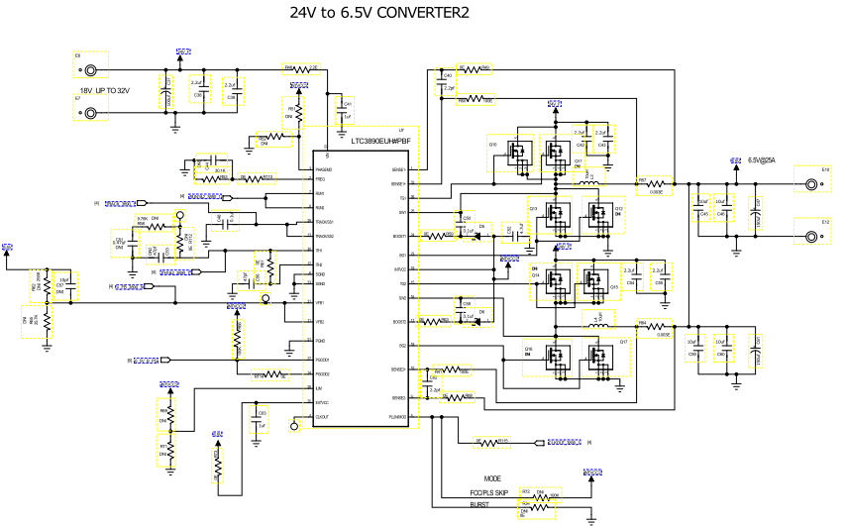

Circuit Parameters :
Input: 24V DC
Output: 6.5V @ 25A
Efficiency: >90% @ full load.

MOSFETS used : Low Ron MOSFETS RJK0651 and RJK0653
Inductors Used : 10uH (16A DC) Henry from Wurth Electronics
Capacitors : Parallel Combination of Electrolytic and LOW ESR Ceramic capacitor
Switching Frequency used : 144Khz

Protection for DC-DC Controller
Current limit
Output Over voltage protection
Power Good output over voltage monitor

LOSS in MOSFETs estimated @full Load : Please refer to section 3.18
LOSS in inductors estimated @full load : Please refer to section 3.18

24V to 3.3v conversion
PCC has few I2C devices like Temperature sensor, EEPROM , I/O Expander and power management IC. These chipsets would work at 3.3V logic. So to energize these ICs, 24V to 3.3V or 6.5V to 3.3V conversion has been done using LT3060.
LT3060 is a low dropout linear regulator.

Features :
- Input Voltage Range: 1.6V to 45V
- Output Current: 100mA
- Quiescent Current: 40µA
- Dropout Voltage: 300mV
- Low Noise: 30µVRMS (10Hz to 100kHz)
- Output Tolerance: ±2% Over Line, Load and Temperature
- Single Capacitor Soft-Starts Reference and Lowers Output Noise
- Shutdown Current: < 1µA
- Reverse Battery Protection
- Current Limit Fold back Protection
- Thermal Limit Protection

Schematic Implementation

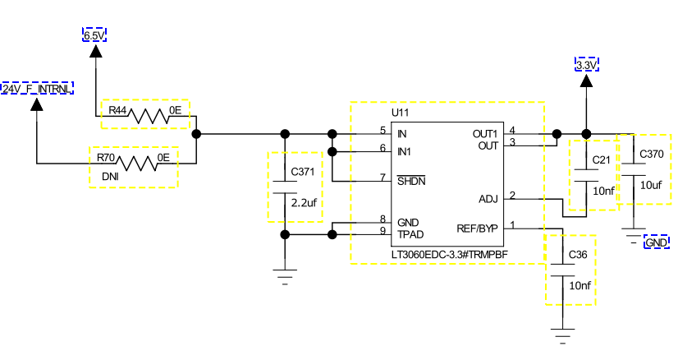
There is provision in PCC, LT3060 can be given input from either 24V or 6.5V. Ic is energized by 6.5V to reduce the power dissipation.

On Board temperature Measurement
Since PCC caries most of the power conversion of the NGP system, there is requirement to measure the on board temperature. This is fulfilled using digital temperature sensor by Analog devices ADT7410.

The ADT7410 is a high accuracy digital temperature sensor in smaller package. It contains a band gap temperature reference and a 13 bit ADC to monitor and digitize the temperature to a 0.0625°C resolution. Operating at 3.3 V, the average supply current is typically 210 μA. The ADT7410 has a shutdown mode that powers
down the device and offers a shutdown current of typically 2 μA. The ADT7410 is rated for operation over the −55°C to +150°C temperature range. ADT has I2C communication protocol which can talk to any decision making devices.
Temperature accuracy
±0.5°C from −40°C to +105°C (2.7 V to 3.6 V)
±0.4°C from −40°C to +105°C (3.0 V)

Schematic Implementation
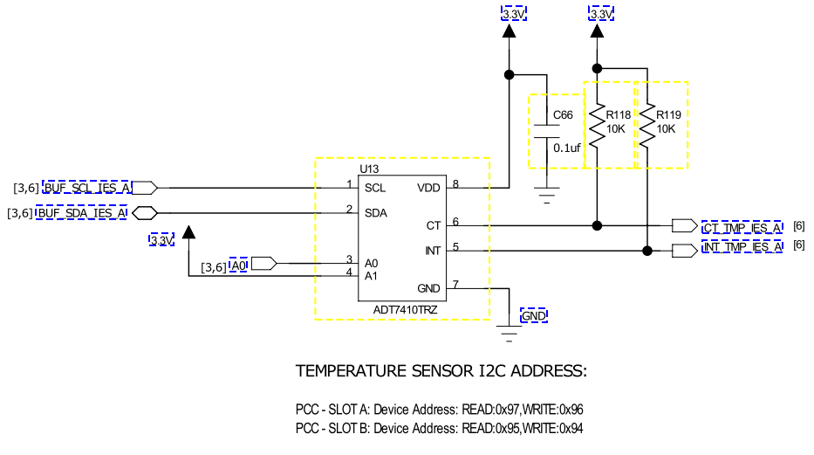

EEPROM Interface
The PCC has on board EEPROM to store the board information. The EEPROM used is
AT24C02BN-SH-B from atmel.

- Internally Organized 256 x 8 (2K)
- Two-wire Serial Interface
- Bidirectional Data Transfer Protocol
- 1 MHz (5V), 400 kHz (1.8V, 2.5V, 2.7V) Compatibility
- Write Protect Pin for Hardware Data Protection
- 8-byte Page (2K) Write Modes

Schematic implementation would be like this

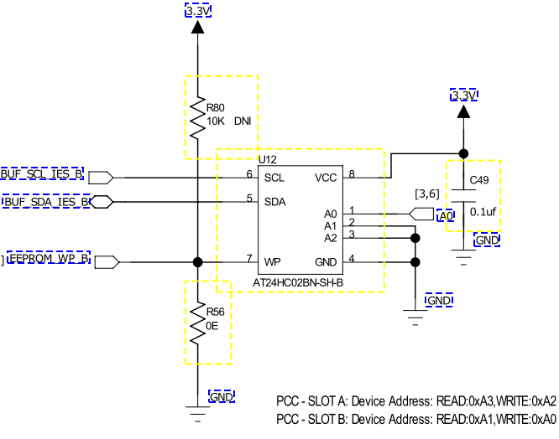

I/O Expander Interface
There is only one I2C line communication/slot from PCC to IES Board. Since PCC board has few power healthy signals from different DC-DC Controllers and hot swap controllers , these information have to send back to IES Board. This is effectively done by I/O Expander. And at the same time Alarm signals from IES boards have been brought to PCC through the expander only. The expander IC used is NXP make PCA9555Bs,118. The PCA9555 is a 24-pin CMOS device that provides 16 bits of General Purpose parallel Input/Output (GPIO) expansion for I2C-bus/SMBus applications.

- Operating power supply voltage range of 2.3 V to 5.5 V
- V tolerant I/Os
- Polarity Inversion register
- Active LOW interrupt output
- Low standby current
- 16 I/O pins which default to 16 inputs
- 0 Hz to 400 kHz clock frequency

Schematic Implementation

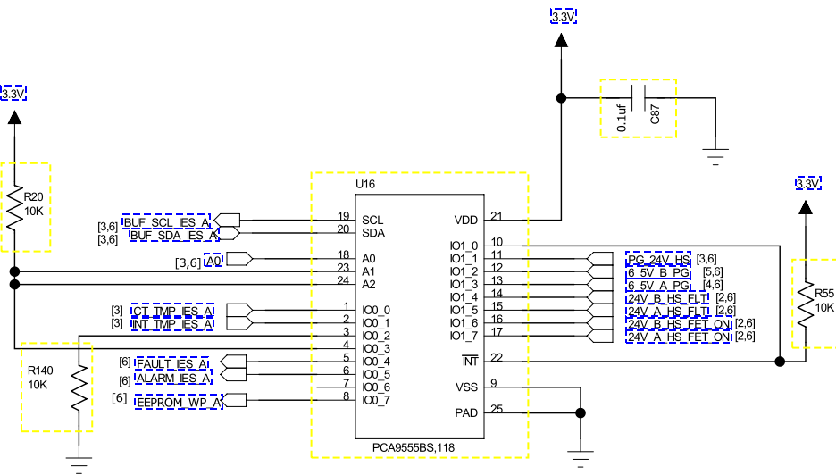

FAULT LED circuit
There is requirement in PCC , that Power good signals from DC-DC Controllers( 24V to 6.5V) and Healthy signal from Hotswap ( 24_F_OUT circuit) should be monitored continuously along with software provided signals from IES Processor ( FAULT signals).

A red LED placed on the front panel of the PCC board, indicates that the board is fault on the PCC. The fault is LED is driven by 24V_F_internal supply, 3 hardware power good signals from LTC3890 (6.5V_A, 6.5V_B, 24_F_OUT) and by firmware using 2 signals named Fault_IES_A and Fault_IES_B. Processors of IES’s monitors PCC’s power good signals of DC-DC converters, temperature, load power and does a mathematics to generate fault signals which reach PCCs via I/O expander chips. The fault signals are active high, hence by default they are active low signals. Circuit is shown below.
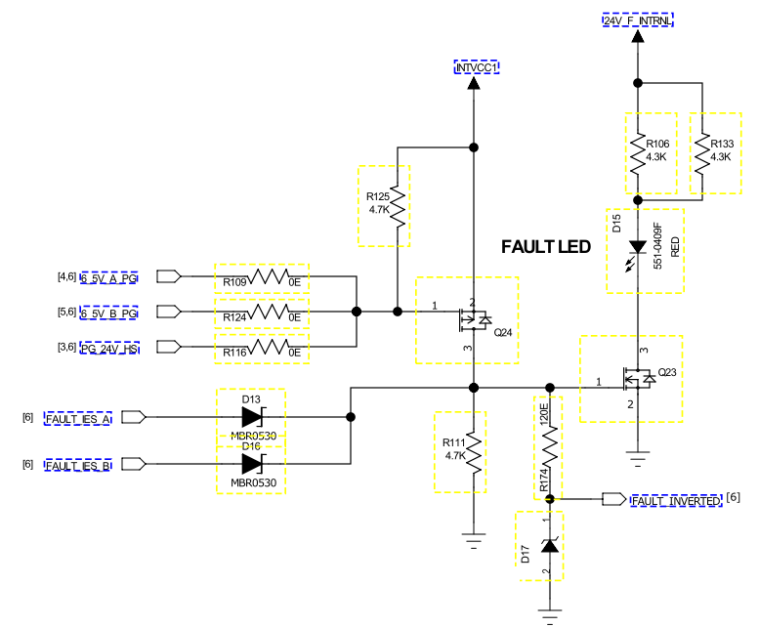

FAULT_INVERETD: An inverted fault LED status input to IES processor. This is useful if the I2C interfaces on IES A&B are not functional.

ALARM LED Circuit
A yellow LED placed on the front panel of the PCC boards indicates that the board is functional yet there is something wrong going on, on the PCCs. The alarm LED is driven by 24V_F_internal supply and by firmware using 2 signals named Alarm_IES_A and Alarm_IES_B. Processors on IES’s monitors PCC’s power good signals of DC-DC converters, temperature, load power and does a math to generate alarm signals which reach PCCs via I/O expander chips. The alarm signals are active high, hence by default they are active low signals. Circuit is shown below.

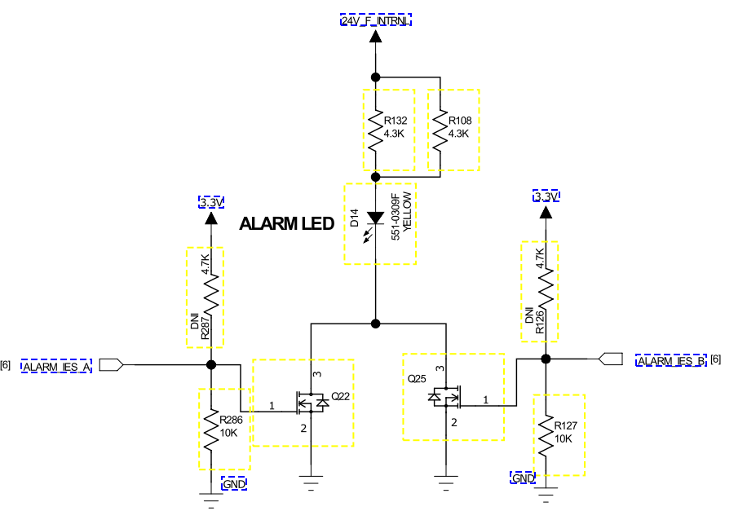

I2C Communication Block diagram
Figure below shows a block diagram of the I2C interfaces implemented on PCC card.

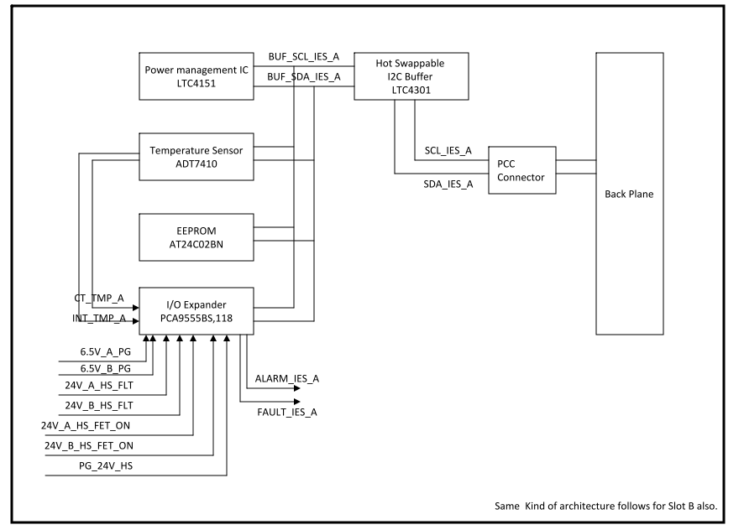

There is single I2C Bus per slot in PCC card. I2C bus is shared among the four devices , Temperature sensor, Power management IC, EEPROM, and I/O expander. Each device has unique addressing scheme so that IES processor should be able access individually. There would be an hot swappable I2C buffer on the PCC to enhance bus drive strength.

Redundancy
Since NGP system would be used in industrial control system, which runs continuously, would require a robust hardware design. So to full fill this requirement, each major circuit stage of the PCC has the redundancy for long run application. The following stages of the PCC have redundancy in their design to ensure the safety of the product.

- Power management IC
- On Board Temperature Measurement
- DC-DC Controller ( 24V to 6.5V Conversion)
- EEPROM Interface
- I/O Expander
- I2C Buffers.

24V_A / 24V_B / Board indicating Front Panel LEDs
24V-A LED: A green LED on the front panel to indicate presence of 24V-A supply on PCC.
24V-B LED: A green LED on the front panel to indicate presence of 24V-B supply on PCC.
2 White LEDs: There are two white LEDs placed on up and down side of the board in order to help the servicemen see.

I2C Device Address
Following table provides the I2C devices addresses for I2C bus from IES-A:

Ref. Des. | MFG P/N | Address | Address(Hex)
U3 | LTC4151HMS#PBF | SLOT-A | 0xD2
 |  | SLOT-B | 0xCE
U13 | ADT7410TRZ | SLOT-A | 0x4B
 |  | SLOT-B | 0x4A
U16 | PCA9555BS,118 | SLOT-A
 |  | READ | 0x4F
 |  | WRITE | 0x4E
 |  | SLOT-B
 |  | READ | 0X4D
 |  | WRITE | 0x4C
U26 | AT24C01BN-SH-B | SLOT-A
 |  | READ | 0xA3
 |  | WRITE | 0xA2
 |  | SLOT-B
 |  | READ | 0xA1
 |  | WRITE | 0xA0

Following table provides I2C devices addresses for I2C bus from IES-B:

Ref. Des. | MFG P/N | Address | Address(Hex)
U1 | LTC4151HMS#PBF | SLOT-A | 0xD2
 |  | SLOT-B | 0xCE
U23 | ADT7410TRZ | SLOT-A | 0x4B
 |  | SLOT-B | 0x4A
U10 | PCA9555BS,118 | SLOT-A
 |  | READ | 0x4F
 |  | WRITE | 0x4E
 |  | SLOT-B
 |  | READ | 0X4D
 |  | WRITE | 0x4C
U12 | AT24C01BN-SH-B | SLOT-A
 |  | READ | 0xA3
 |  | WRITE | 0xA2
 |  | SLOT-B
 |  | READ | 0xA1
 |  | WRITE | 0xA0

PCC Card connector
The connector used for PCC card to back plane is 51720-10401204AA from FCI. This particular connector is POWER + data signal connector.

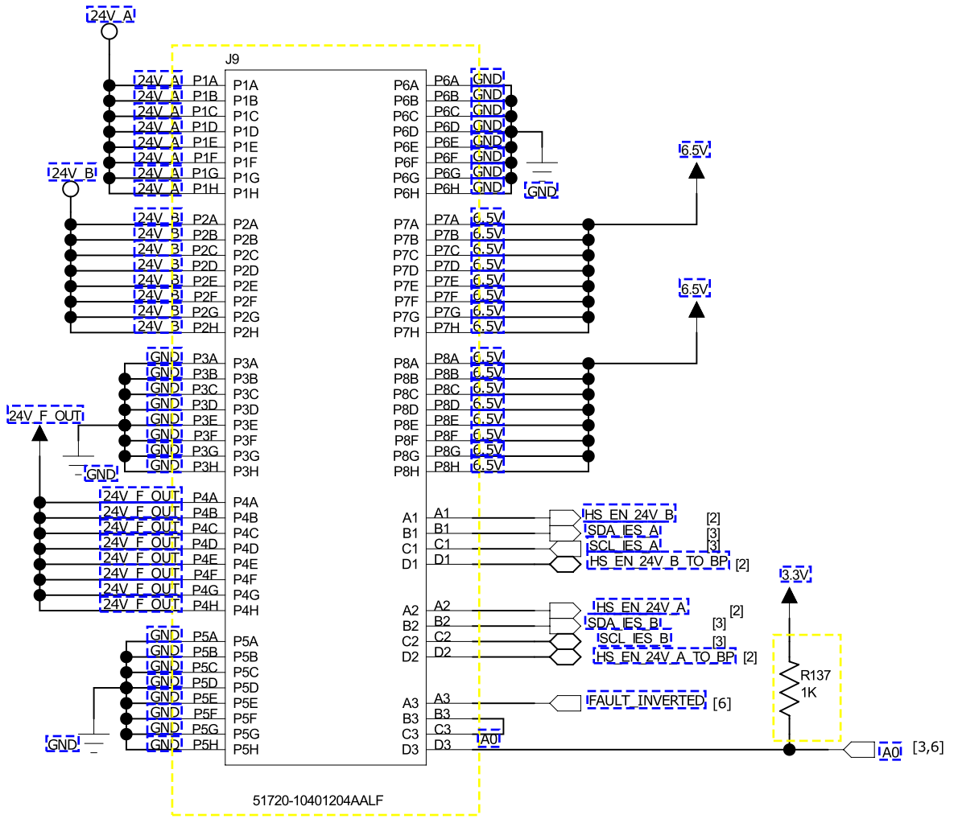

Signal Description

Power Pins:

24V_A: 24V_A DC supply input to PCC
24V_B: 24V_B DC supply input to PCC
24V_F_OUT: 24V filtered and reverse polarity protected DC supply output from PCC to IOPs of the NGP System
6.5V: 6.5V DC supply out to all boards in NGP from PCC
GND : Common return path

Signal Pins:

Data Pins:

HS_EN_24V_A_TO_BP: 24V supply enable signal for 24V_A supply hot swap, that goes to back plane and comes back on another pin(HS_EN_24V_A) to make sure PCC is inserted properly into the back plane and then enabling hot swap. These two signals will be shorted on backplane.

HS_EN_24V_B_TO_BP: 24V supply enable signal for 24V_B supply hot swap that goes to back plane and comes back on another pin(HS_EN_24V_B) to make sure PCC is inserted properly into backplane and then enabling hot swap. These two signals will be shorted on backplane.

SCL_IES_A, SDA_IES_A: I2C bus that comes from IES-A board processor
SCL_IES_B, SDA_IES_B: I2C bus that comes from IES-B board processor

FAULT_INVERETD: An inverted fault LED status input to IES A and B. This is useful if the I2C interfaces on IES A&B are not functional.

A0: This signal enables Processors on IES to differentiate PCCs by differently configuring LSB of all I2C devices on both PCC slots. The I2C devices of PCC card inserted in PCC slot A will have a different set of addresses compared to the one inserted in slot-B

I2C I/O expanders: There are two I2C I/O expander chips on PCC that help increase I/Os that can communicate to both IES. A PCC should communicate to both IES simultaneously, hence two I/O expanders. The I/Os are bidirectional.

Card Guide connector
Since PCC has to fix to the back plane of the NGP system, there is card guide which makes this possible. The card guide holds the PCC card firmly , so that there is no any fragile movement of card with respect to back plane. The card guide used is 10045597-103LF from FCI. Since card guide is connected to chassis , common return path of the board is connected to Chassis with low impedance path to improve EMI performance of the board. Schematic implementation is shown below.
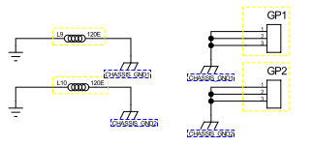

Loss Estimation of the PCC Card @ full load.

The following file provides the complete lost estimation of the PCC card at full load.



Front Panel LEDs List

Table below describes the LEDs used on front panel

Name | Description | Controlled by | Label | Color | No of LEDs
Power | 24V_A Supply is available | Hardware | 24V_A | Green | 1
Power | 24V_B Supply is available | Hardware | 24V_A | Green | 1
Alarm | Card has a detectable non-critical issue | SW | ALARM | Yellow | 1
Fault | Card has a critical issue | SW/HW | FAULT | Red | 1
Board indicating LEDS | For service men | Hardware |  | White | 2

Schematic Design

Design Tool
Schematic entry is done PAD9.4

Board Layout Design

Board Thickness
Thickness of the Board designed is 1.6mm±10% [0.063” ± 10%]

Board Stack-up
The PCC Board is designed with six layer stack-up with no blind or buried vias. And the copper thickness of the each layer is 2 oz. (70 microns).Most of the components are placed top side of the board except for few discrete which are placed on bottom.

